# BARCODES:

Barcode labels are useful tools for tracking assets and inventory across organizations and through the entire supply chain, but what type of barcode is most suitable for your needs? A myriad of barcode symbologies exist, some of which are better suited to different types of applications than others. Additionally, some industries have standards which aim to regulate the labeling of assets and physical inventory in order to establish universal practices for industry-wide consistency, making it easier to transfer assets and data to other organizations.

## [The Main Types of Barcodes](https://www2.camcode.com/asset-tags/guide-to-barcode-types-standards/#BarcodeTypes):

* [Numeric-Only Barcode Symbology’s](https://www2.camcode.com/asset-tags/guide-to-barcode-types-standards/#Numeric)
* [Alpha-Numeric Barcode Symbology’s](https://www2.camcode.com/asset-tags/guide-to-barcode-types-standards/#AlphaNumeric)
* [Two-Dimensional Barcode Symbology’s](https://www2.camcode.com/asset-tags/guide-to-barcode-types-standards/#2DBarcodes)
* [Barcode Standards and Specifications](https://www2.camcode.com/asset-tags/guide-to-barcode-types-standards/#StandardsandSpecs)

\*Numeric-only Barcodes:

Barcode only consists of number

\*Alpha-Numeric Barcodes:

Barcode contain combination of numerical and character.

\*Two-dimension Barcodes:

are in the shape of a square or rectangle and contain many small dots arranged in a unique pattern.

The main benefit of 2D barcodes is that they can hold much larger amounts of data in a small space, and they remain legible even when printed or etched into a product in small sizes. 2D barcodes are used in a variety of industries ranging from manufacturing and logistics to warehousing and healthcare. A QR code is just one example of a 2D barcode that most people have encountered.

Divided by character sets, 1D barcodes and 2D barcodes can be categorized into three different groups, as the table below shows:

|  |  |  |
| --- | --- | --- |
| Character Set | 1D Barcode | 2D Barcode |
| Numeric | [UPC-A](https://www.dynamsoft.com/blog/insights/the-comprehensive-guide-to-1d-and-2d-barcodes/#_UPC_A), [UPC-E](https://www.dynamsoft.com/blog/insights/the-comprehensive-guide-to-1d-and-2d-barcodes/#_UPC_E), [EAN 13](https://www.dynamsoft.com/blog/insights/the-comprehensive-guide-to-1d-and-2d-barcodes/#_EAN_13), [EAN 8](https://www.dynamsoft.com/blog/insights/the-comprehensive-guide-to-1d-and-2d-barcodes/#_EAN_8), [Industrial 2 of 5](https://www.dynamsoft.com/blog/insights/the-comprehensive-guide-to-1d-and-2d-barcodes/#_Industrial_2_of), [Interleaved 2 of 5](https://www.dynamsoft.com/blog/insights/the-comprehensive-guide-to-1d-and-2d-barcodes/#_Interleaved_2_of), [Codebar](https://www.dynamsoft.com/blog/insights/the-comprehensive-guide-to-1d-and-2d-barcodes/" \l "_Codabar), [Code 11](https://www.dynamsoft.com/blog/insights/the-comprehensive-guide-to-1d-and-2d-barcodes/#_Code_11) |  |
| Alpha-numeric | [Code 39](https://www.dynamsoft.com/blog/insights/the-comprehensive-guide-to-1d-and-2d-barcodes/#_Code_39), [Code 93](https://www.dynamsoft.com/blog/insights/the-comprehensive-guide-to-1d-and-2d-barcodes/#_Code_93) |  |
| Full ASCII | [Code 128](https://www.dynamsoft.com/blog/insights/the-comprehensive-guide-to-1d-and-2d-barcodes/#_Code_128) | [QR Code](https://www.dynamsoft.com/blog/insights/the-comprehensive-guide-to-1d-and-2d-barcodes/#_QR_code), [Data Matrix](https://www.dynamsoft.com/blog/insights/the-comprehensive-guide-to-1d-and-2d-barcodes/#_Data_Matrix), [PDF417](https://www.dynamsoft.com/blog/insights/the-comprehensive-guide-to-1d-and-2d-barcodes/#_PDF417) |

**UPC codes** :

-One of the most commonly used barcode symbologist, and arguably the most recognized barcode type by consumers due to the widespread use of UPC codes in retail settings.

-12-digit UPC codes (UPC-A) contain basic information about the manufacturer’s identity and the -identification number for the product, but more information can be gained by looking up UPC codes -with a service such as [UPC Database](http://upcdatabase.org/instant) or [GTIN](http://www.gtin.info/check-company-prefix/),

- which is the official bar code assignment organization in the United States.

-[Each digit’s position](http://www.wikihow.com/Read-12-Digit-UPC-Barcodes) reveals the type of information those numbers refer to, a standardized process that makes it possible to decipher UPC codes that did not originate within a specific company.

There are also more basic UPC-E variations containing only 6 digits.

## **UPC-A**

**What is it?**

The UPC-A bar code was created by IBM in 1971. Nowadays it’s found on virtually every consumer goods packaging. This includes on the shelves of your local supermarket, as well as books, magazines, and newspapers.

UPC-A encodes 11 digits of product information data along with a trailing check digit, for a total of 12 digits of bar code data. The 11 product digits are further divided into three logical categories.

* The first digit represents the information regarding the type of the product.
* The next five digits contain information about the manufacturer of the product.
* The last five digits contain information about the particular product being encoded.

An example of a typical UPC-A bar code is:

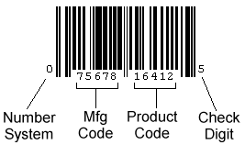

**Where is it used?**

The UPC-A bar code is widely used all over the world for scanning of trade items at the point of sale.

**Industry**

Retail, Warehousing

## **UPC-E**

**What is it?**

The UPC-E is a variation of the [UPC-A](https://www.dynamsoft.com/blog/insights/the-comprehensive-guide-to-1d-and-2d-barcodes/#_Code_39) which allows for a more compact barcode by compressing out unnecessary zeros. This helps result in the UPC-E barcode being only about half the size of a UPC-A barcode. So, the UPC-E can generally be used in a very small space where a full [UPC-A](https://www.dynamsoft.com/blog/insights/the-comprehensive-guide-to-1d-and-2d-barcodes/#_Code_39) barcode couldn’t reasonably fit.

Original UPC-A Barcode:  
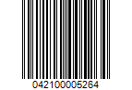  
Equivalent UPC-E Barcode:

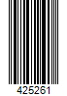

As UPC barcodes, [UPC-A](https://www.dynamsoft.com/blog/insights/the-comprehensive-guide-to-1d-and-2d-barcodes/#_UPC-A) and UPC-E contain only numerals. So, they should be used on simple and retail stores product that generally do not require complex information encoding.

**Where is it used?**

The UPC-E barcode is used in retail and warehousing, especially in the USA and Canada.

**Industry**

Retail, Warehousing

**EAN codes** :

-Similar to UPC codes, [EAN codes](http://support.quickbooks.intuit.com/opencms/sites/default/IPH/pos/posv7_ms/qbpos_basic_procedures/basic219.htm) are used to identify consumer products worldwide and are designed for Point-of-Sale (POS) scanning.

- Interestingly, while many retail locations scan product UPC codes, scanners typically [convert UPC codes](http://www.adams1.com/upccode.html) to the 13-digit EAN format. There are a few different variations of the EAN barcode, including  EAN-13, EAN-8, JAN-13, ISBN, and ISSN.

## **EAN 13**

**What is it?**

The International Article Numbering Association (EAN) in Europe designed the EAN-13 barcode type. Most European countries are using this barcode type.

EAN-13 is a 13-digit (12 data and one check) barcoding standard which is a superset of the original 12-digit Universal Product Code (UPC) system. Therefore, any software or hardware capable of reading an EAN-13 symbol should automatically be able to read an [UPC-A](https://www.dynamsoft.com/blog/insights/the-comprehensive-guide-to-1d-and-2d-barcodes/#_Code_39) symbol.

The 13 digits in the EAN-13 barcode are grouped as follows:

* 2 or 3 digits for number system or country code
* 5 or 4 digits for manufacturer (company) code or prefix
* 5 digits for product code
* 1 digit for checksum

A typical EAN-13 bar code looks something like this:

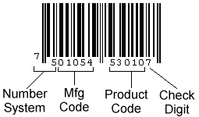

Since 2005, all retail scanning systems in the USA have accepted the EAN-13 symbol as well as the standard UPC-A. So, it is recommended that all new designs implement EAN-13 rather than UPC-A. This will make your software/hardware appealing to the international community. It also eliminates the need for manufacturers who export goods to the US and Canada to double-label their products.

**Where is it used?**

The EAN-13 barcode is used worldwide for marking products often sold at retail stores and point of sales.

**Industry**

**Retail**

## **EAN 8**

**What is it?**

An EAN-8 barcode is derived from the longer European Article Number ([EAN-13](https://www.dynamsoft.com/blog/insights/the-comprehensive-guide-to-1d-and-2d-barcodes/#_EAN_13)) code. The main purpose of the EAN-8 bar code is to use as little space as possible.

An EAN-8 bar code includes a two or three-digit country code, four of five data digits (according to the length of the country code), and a checksum digit. The data digits in an EAN-8 symbol identify a specific product and manufacturer.  
EAN-8

EAN-8 is encoded using the three EAN-13 character sets and also has a check digit that is calculated in the same manner as EAN-13. There is a limited number of EAN-8 bar codes available in each country. So, they are issued only for products with insufficient space for an EAN-13 symbol.

**Where is it used?**

You’ll find EAN-8 barcodes on products where only limited space is available, like small candies, cigarettes, pencils, and chewing gum packets.

Companies may also use EAN-8 barcodes to encode RCN-8s (8-digit Restricted Circulation Numbers) used to identify own-brand products sold only in their stores.

**Industry**

Retail

**Industrial 2 of 5 codes:**

-These barcodes are not as commonly used as other types of 1D barcodes. Industrial 2 of 5 barcodes contain two thick bars and three thin bars, and the space between bars is a fixed width.

-Once a widely used barcode, [Industrial 2 of 5](http://www.barcodefonts.net/Industrial2of5_Barcode.html) codes may have become less popular due to their low density. Industrial 2 of 5 codes are still in use in some warehouses today, however.

## **Industrial 2 of 5**

**What is it?**

Industrial 2 of 5 is a low-density numeric symbol that has been with us since the 1960s. The barcode is called “2 of 5” due to the fact that digits are encoded with five bars, two of which are always wide (and the remaining three are narrow).

Industrial 2 of 5 is a very simple symbol in that all information is encoded in the width of the bars. The spaces in the barcode exist only to separate the bars themselves.

A typical Industrial 2 of 5 barcode looks like this:

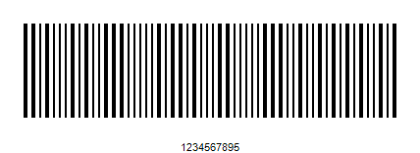

**Where is it used?**

Industrial 2 of 5 has been used in photofinishing, transport and warehouse sorting applications, as well as for sequentially numbering airline tickets.

**Industry**

Transport, Warehousing

Interleaved 2 of 5 – A newer and slightly more sophisticated variation of the Industrial 2 of 5 code, the [Interleaved 2 of 5 barcode](http://www.barcode.ro/tutorials/barcodes/interleaved2of5.html) has the same basic format, but the spaces between bars do not have a fixed width. Thus, both the bar and space width is used to encode information in the Interleaved 2 of 5 barcode. Characters in even positions are encoded in bars, while characters in odd positions are encoded in spaces. Interleaved 2 of 5 codes can encode any even number of numeric characters.

## **Interleaved 2 of 5**

**What is it?**

Interleaved 2 of 5 is a higher-density numeric symbol based upon the [Industrial 2 of 5](https://www.dynamsoft.com/blog/insights/the-comprehensive-guide-to-1d-and-2d-barcodes/#_Industrial_2_of)symbol. It’s a more efficient implementation of Industrial 2 of 5. Interleaved 2 of 5 allows information to be encoded in both the bars and spaces, whereas ([as previously explained](https://www.dynamsoft.com/blog/insights/the-comprehensive-guide-to-1d-and-2d-barcodes/#_Industrial_2_of)) Industrial 2 of 5 only encodes information in the width of the bars.

Each data character consists of five elements, either five bars or five spaces. Of these five elements, two are wide and three are narrow. The symbol is termed “interleaved” because the first numeric data is encoded in the first five bars while the second numeric data is encoded in the first five spaces that separate the first five bars. Thus the first five bars and spaces actually encode two characters. This feature allows Interleaved 2 of 5 to achieve a relatively higher density, but users must always encode an even number of numeric values.

A typical Interleaved 2 of 5 bar code appears like this:

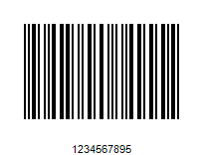

Note that the above bar code is physically smaller than [Industrial 2 of 5](https://www.dynamsoft.com/blog/insights/the-comprehensive-guide-to-1d-and-2d-barcodes/#_Industrial_2_of).



**Where is it used?**

Interleaved 2 of 5 is used primarily in applications such as label packaging, distribution and warehousing. Since the barcode can deal with high printing tolerances, it is good for printing on corrugated cardboard.

**Industry**

Packaging, Logistics

## Two-Dimensional Barcode Symbologies:

**QR-CODE:** QR codes, which stands for ‘quick-response code,’ are among the most widely recognized two-dimensional barcodes thanks to their widespread use for bridging the gap between the digital world and the real world.

The [QR code](http://www.dataintro.com/lit/wp2dbarcodes.pdf) is capable of encoding up to 2,509 numeric or 1,520 alphanumeric characters and has three levels of error-detection built in. QR codes are a minimum of 21×21 cells but can increase in size in increments of 4×4 cells up to a maximum size of 105×105 cells. You’ll find QR codes on everything from cereal boxes to posters, advertisements, and even [museums](https://blog.kissmetrics.com/genius-qr-codes/), [beverage cups](http://www.marketingprofs.com/articles/2014/24499/proper-and-improper-use-of-qr-codes-10-great-examples-of-each), library books, and more.

## **QR code**

**What is it?**

The QR code is a type of matrix barcode that can encode a wide variety of data types, including numeric, alphabets, special characters and binary data as well. These are the ones you see nowadays with a series of black and white cells rather than the more familiar black lines or bars. They really rose in popularity with mobile devices. It was initially developed by Toyota subsidiary Denso in September 1994. It’s currently defined by the International Organization for Standardization(ISO)/The International Electrotechnical Commission (IEC) 18004.

The QR code was designed to allow high-speed component scanning. A charge-coupled device (CCD) barcode reader can decode up to 30 QR codes per second with up to 100 characters in each barcode.

The QR code has full (360 degrees) reading features. Each QR code has three finder patterns located in three corners of the QR code. A CCD reading device can detect and decode the position of the barcode, the size of the barcode and the size of the inclination angle.

This barcode type has a high data density. It can encode 1,817 Chinese characters, 7,089 numbers or [4,296 English letters](http://twainscanning.com/can-your-mobile-read-this-barcode/). It has four levels of error correction. Even if a QR code is damaged or broken, it can often still be read correctly.

A common QR code appears like such:

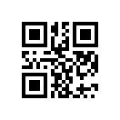

**Where is it used?**

Today, QR codes have become common in areas such as consumer advertising, code payments, website logins, for data encryption, and more.

**Industry**

Retail, Entertainment and Advertising

**Data Matrix** – According to [JPGraph.net](http://jpgraph.net/download/manuals/chunkhtml/ch26.html), data matrix barcodes “can encode up to 3,116 characters from the entire 256 byte ASCII character set.” It’s a high-density 2D barcode, offering greater data density compared to PDF417 barcodes.

* Data matrix barcodes are configured in a square grid with a finder pattern around the edges of the symbol that enable scanners to identify the barcode and to read it regardless of the code’s orientation.
* Like other 2D barcodes, data matrix barcodes contain built-in error correction measures to ensure the integrity of the data even if the code is damaged physically.
* [**Data matrix codes**](http://www.tec-it.com/en/support/knowbase/symbologies/datamatrix/Default.aspx) are used primarily in **the U.S. and Europe**, most frequently for applications such as direct part marking and laser marking in the aerospace, electronic, and automotive industries, although data matrix codes are also used for logistics, document management, postal services, and healthcare applications.

## **Data Matrix**

**What is it?**

Data Matrix barcode is also a two-dimensional matrix barcode. It first came about in 1994, and today, it is represented by the standard ISO/IEC 16022. The Data Matrix barcode supports advanced encoding error checking and correction algorithms. This allows the recognition of barcodes that are up to 60 percent damaged. So, it’s commonly used on items where barcodes get easily damaged due to high heat, chemical exposure, etc. As a result, Data Matrix barcodes are used in electrical rating plates, surgical instruments, circuit boards and the like.

Data Matrix barcodes are adaptable in size. The symbol size can be as small as 2.5mm, which is the smallest among all 2D barcodes. Meanwhile, the size and the encoded data capacity is independent. This allows the choosing of a lot of different matrix sizes.

A common Data Matrix bar code can appear like this:

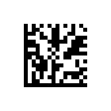

**Where is it used?**

The most popular application for Data Matrix is labeling small items, such as small electronic components and pill bottles.

**Industry**

Electronics, Retail, Government, Marketing, Post, Electronics, Medical

* **PDF417** – As [TEC-IT explains](https://www.tec-it.com/en/support/knowbase/symbologies/pdf417/Default.aspx), “PDF417 is a 2d barcode (stacked symbology) used in a variety of applications, primarily transport, identification cards, and inventory management. PDF stands for Portable Data File and was developed by Symbol Technologies. PDF417, or Portable Data File 417, uses built-in error correction to ensure better readability.” PDF417 barcodes can encode one to two hundred characters per symbol, or [more than a kilobyte of data](https://racoindustries.com/barcodegenerator/2d/pdf417/) per label.  PDF417 was developed by Symbol Technologies (1989-1992) and is currently maintained by **ISO/IEC**.
* PDF417 barcodes are used in logistics applications, transport systems, identification for items such as **driver’s licenses and passsports, and document management applications.** With a slightly different composition compared to other 2D barcodes, PDF417 barcodes can be described as a set of linear barcodes stacked on top of one another, thus why they are sometimes described as a “stacked linear symbology.”

## **PDF417**

**What is it?**

The PDF417 barcode is a type of stacked linear barcode. Symbol Technologies was said to have developed this barcode type back in 1991. Today, it is represented by ISO standard 15438.

Each PDF417 barcode consists of three to 90 rows, and a single row is essentially the equivalent of a small 1D barcode. PDF417 specifies that each pattern in the code consists of four bars and spaces, and each pattern is to be 17 units long. This is how we get the “417” part of the name.

A common PDF417 bar code looks like this:

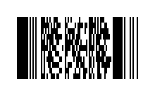

**Where is it used?**

The PDF417 barcode type is mainly used in transportation, identification cards and inventory management. Most states in America use PDF417 to encode drivers’ key information on the back side of driver licenses.

**Industry**

Transport, Logistics, Warehousing, Government

**Aztec** – Aztec codes are predominantly used in the transportation industry for applications such as **tickets and airline** boarding passes. These codes are not as widely supported by open-source software as QR codes, however, so they should be used only in circumstances in which they are supported by proprietary software systems. Compared to QR codes, Aztec codes [require less space](http://stackoverflow.com/questions/27857718/aztec-barcode-vs-qr-code) yet can store more information, but because they are not as widely supported by readily available software, they can be more difficult to read and generate efficiently. Notably, however, Aztec codes are [better for being displayed](http://www.masabi.com/2011/03/04/connecting-the-dots-an-introduction-to-2d-barcodes-3/) on mobile devices such as smartphones, making them a suitable choice for fast-paced transportation services where rapid scanning is a must.

Tasks: BARCODE LOCATION

BARCODE DECODING

PYZBAR: OPENCV: ,EAN-8/EAN-13,UPC-A/UPC-E, CODE128, CODE19, CODE BAR,INTERLEAVED 2 OF 5

ALGO:

IMAGE-GREY IMAGE- BINARIZED-ALGO

NUMPY-NORMAL BARCODE ONLY 1 -D

* Pure python
* Works with PIL / Pillow images, OpenCV / numpy ndarrays, and raw bytes
* Decodes locations of barcodes
* No dependencies, other than the zbar library itself
* Tested on Python 2.7, and Python 3.4 to 3.6

The older [zbar](https://sourceforge.net/p/zbar/code/ci/default/tree/python/) package is stuck in Python 2.x-land. The [zbarlight](https://github.com/Polyconseil/zbarlight/) package does not provide support for Windows and depends upon Pillow.

# NEURAL NETWORK😊

Zxing – Tensor -flow ,(best barcode detected using android )

ZXing ("zebra crossing") is an open-source, multi-format 1D/2D barcode image processing library implemented in Java, with ports to other languages.

#### **Benefits and Features:**

**Technicla Support**: Technical support for new Android/iOS versions and for android device compatible issues.

**15 Types**: Supports all ISO 2D barcodes (QR Code, DataMatrix, PDF417, Maxicode, Aztec) as well as popular 1D barcodes (EAN13/ISBN/UPC, EAN8, Code11, Code39, Code93, Code128, Interleaved 2 of 5, Industrial 2 of 5, MSI)

**360 Degrees**: Omni-directional scanning for 360 degrees.

**1 Second**: Decodes under one second!

**8 Conditions**: Scannable barcode conditions include blurred, scaling, mirrored, inversed, broken, rotated, distorted and unbalanced lighting conditions.

**10 Minutes**: Integrate into your APP within 10 minutes with sample codes! Save time and money!

**2 Platforms**: Supports iOS and Android.

**Experiences**: Improve the QR Code scanning user experience of your APP and reduce user complains.

**Functions**: Extra functions to meet your needs, such as file scan, area scan, light on/off etc.

**Excellent**: Customized service for your special requirements, such as read multiple 1D/2D barcodes, special QR codes, special sizes or environment etc.

| **1D product** | **1D industrial** | **2D** |
| --- | --- | --- |
| UPC-A | Code 39 | QR Code |
| UPC-E | Code 93 | Data Matrix |
| EAN-8 | Code 128 | Aztec (beta) |
| EAN-13 | Codabar | PDF 417 (beta) |
|  | ITF | MaxiCode |
|  |  | RSS-14 |
|  |  | RSS-Expanded |

|  |  |  |  |  |  |  |  |  |  |  |  |  |  |  |  |  |  |  |  |  |  |  |  |  |  |  |  |  |  |  |  |  |
| --- | --- | --- | --- | --- | --- | --- | --- | --- | --- | --- | --- | --- | --- | --- | --- | --- | --- | --- | --- | --- | --- | --- | --- | --- | --- | --- | --- | --- | --- | --- | --- | --- |
| |  |  |  |  | | --- | --- | --- | --- | | Supported Formats QR CODE TYPICAL TYPES | FUN2d SCANNING CAPACITY(PYXING) | FUN2d SCANNING CAPACITY(PYZBAR) |  | | NORMAL QR | YES | YES |  | | ROTATION QR | YES | YES |  | | HORIZONTAL DISTORATION | YES | YES |  | | VERTICAL DISTORTAION | YES | YES |  | | MIRROR QR | YES | YES |  | | INVERSE QR | YES | YES |  | | BLURRED QR | YES | YES |  | |

[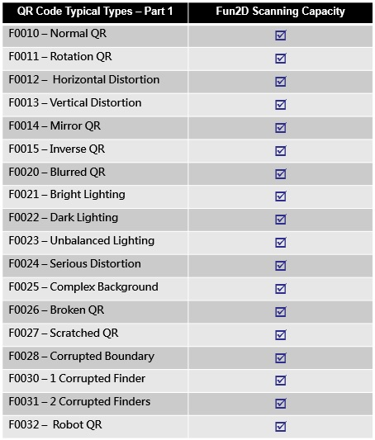](https://www.funcode-tech.com/images/F1001_Fun2D_SDK_Table01.JPG)

[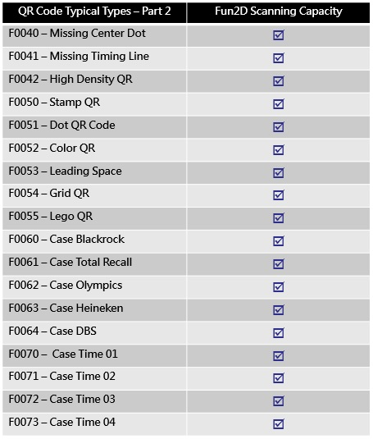](https://www.funcode-tech.com/images/F1002_Fun2D_SDK_Table02.JPG)

[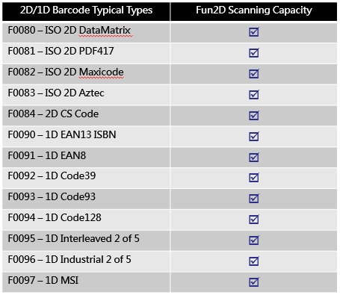](https://www.funcode-tech.com/images/F1003_Fun2D_SDK_Table03.JPG)

**How neural network help in barcode detection:**

### **Image Restoration**

Restoration of an original image from a degraded version is a fundamental early vision task attempting to recover visual information lost during the acquisition process, without introducing any distorting artifacts.

**Robust,** blind or semi-blind solutions to image restoration are becoming increasingly important as imaging technology is rapidly advancing and finds more applications in which physical and environmental conditions can not be known reliably hampering or precluding estimation of the degrading point spread function (PSF) or the degree and type of noise present.